Calculus 1 Lecture 2.1: Introduction to the Derivative of a Function
The Derivative
The slope of a curve at a point

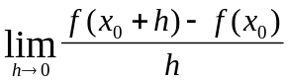

Derivative Notation
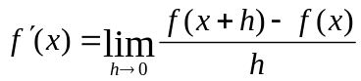

Example
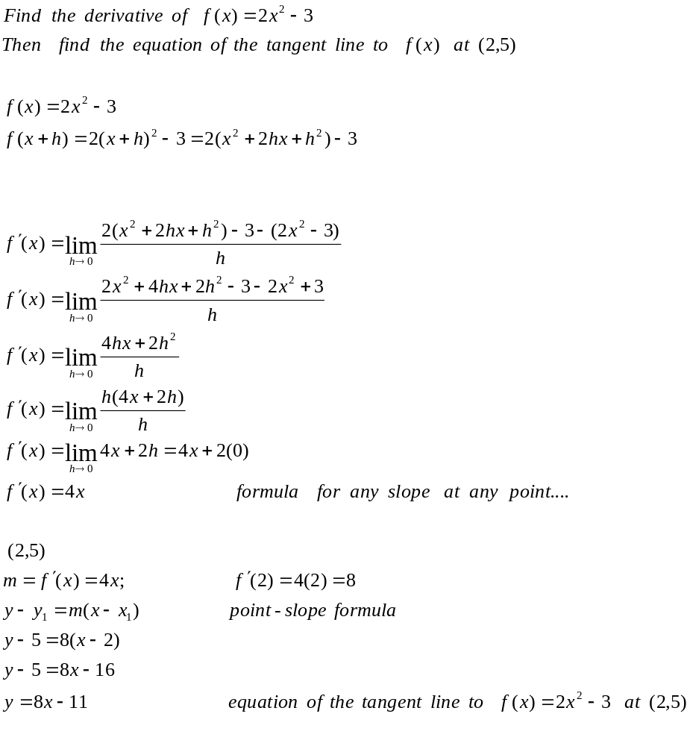
Example
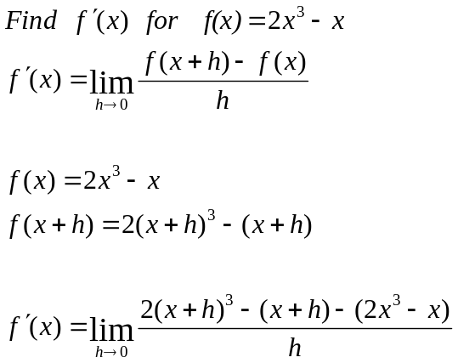

Pascal’s Triangle

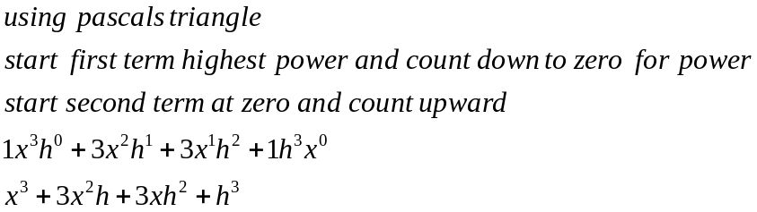

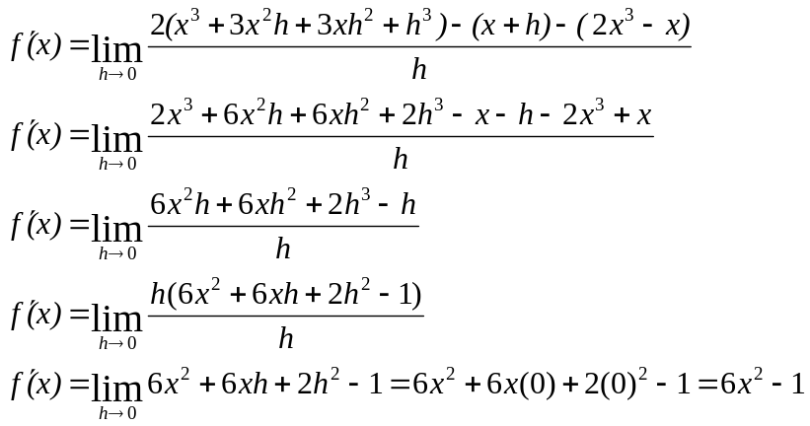

Example
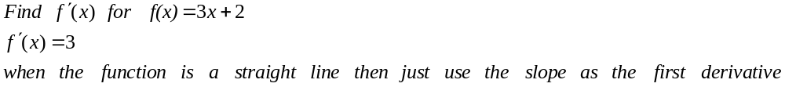

Example
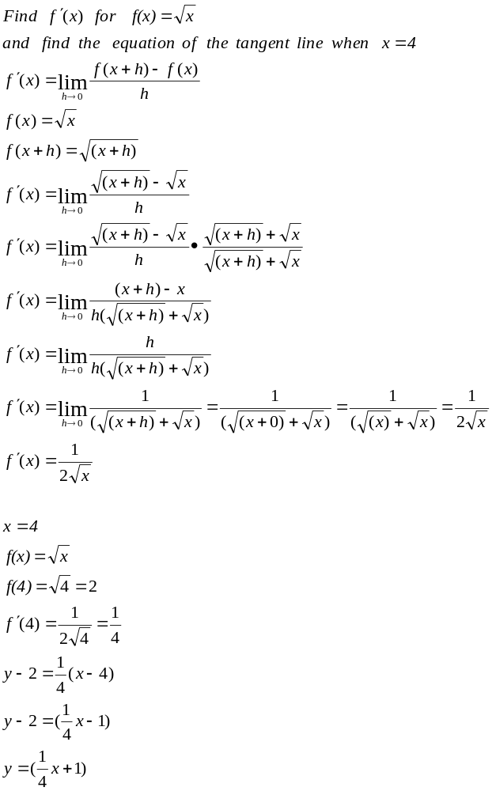

Instantaneous velocity is the first derivative of a position curve.
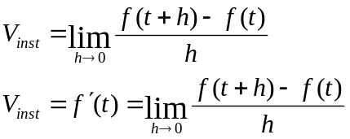

Example
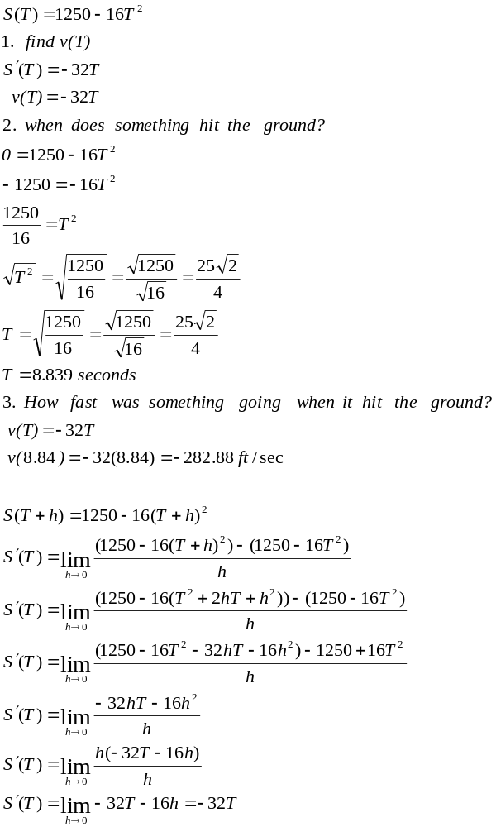r

Differential ability
In order for a derivative to exist at a point
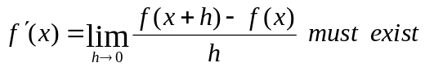Differential ability

At a point if the slope of the point from the right does not equal the slope of the point from the left using limits do not equal then a derivative at the point does not exist
Sharp points or vertical lines

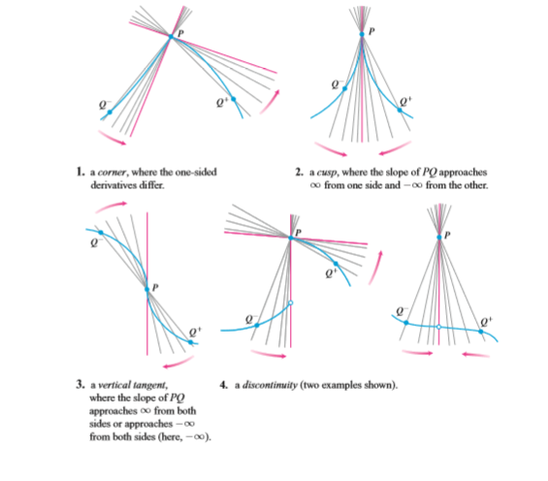

Representations of Derivatives
